Online Benchmark Assessments
Reports

5 Types of Reports:

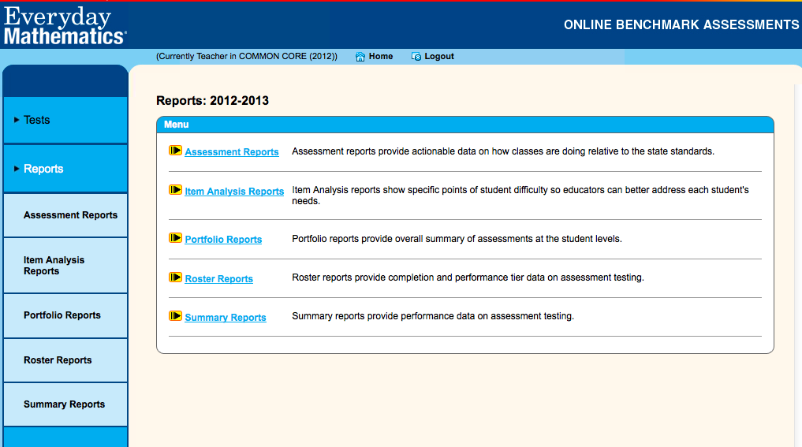

- Item Analysis
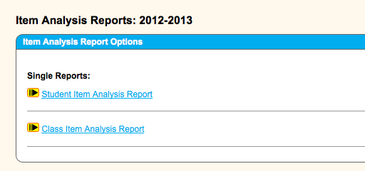
Begin with the class item analysis.

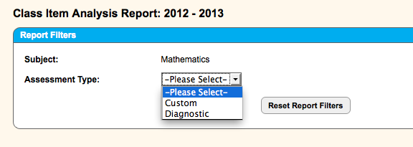

For ALL reports, chose Diagnostic.

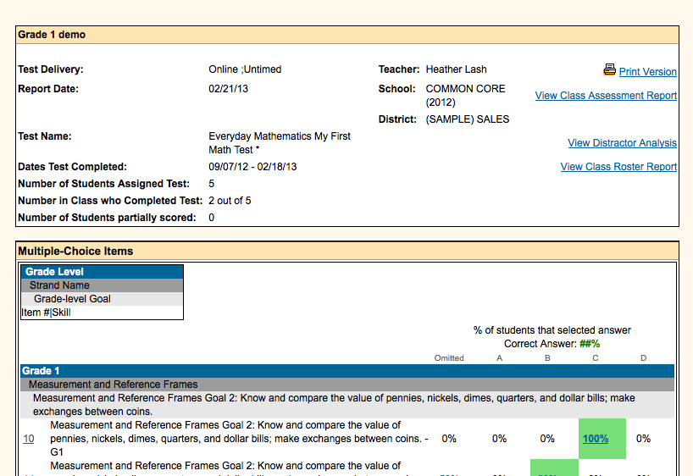

** This report provides a variety of information.
- You can quickly check that all students have completed the test in the summary box.
- Identifies EM grade level goal for each question. I would recommend printing a copy of the test from the TEST link and write next to each question the goal. This is helpful for finding interventions in the Assessment Differentiation System.
- Click on the item number on the left to see comparative data for your class compared to school and district.
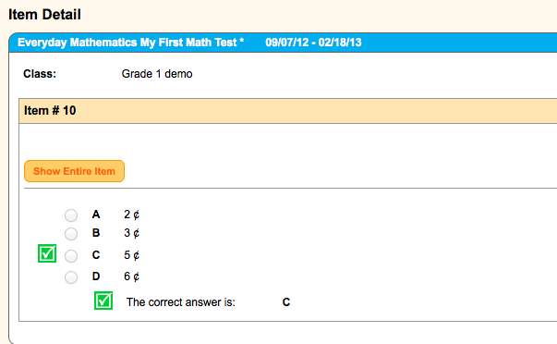
Click on “Show entire item” to see the comparisons.
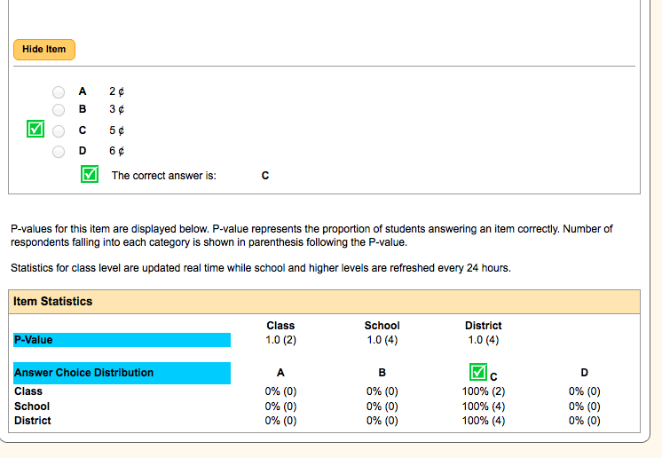
You are then able to see how your class performed compared to the school and district.

** Go back to the item analysis. There are a few more features in this report:
- The percent in green is the correct answer. If you click on any of the percents, you will see which students responded with that answer choice.
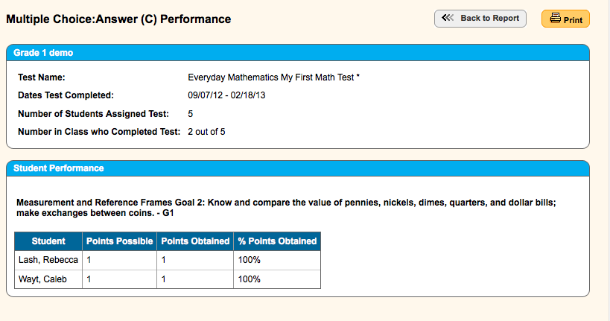

- Finally, near the top of the item analysis report, click on the distractor report to see possible reasons why the child missed a problem.
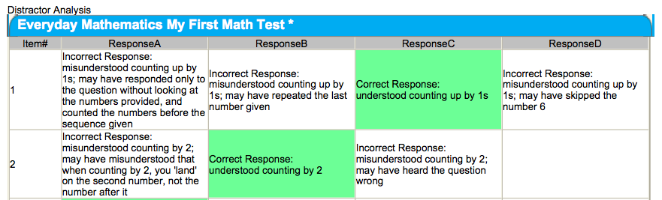

ROSTER Report

This report will give you a quick look at how your students performed on the assessment. You can sort them from low to high by clicking on the center column at the top.
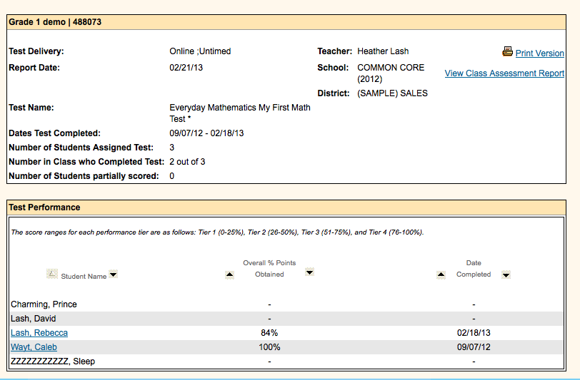

If you click on a child’s name, it will open a report for that student.

PORTFOLIO Report

This is a perfect way to look at an individual student’s progress from one assessment to the next. This is also helpful to see growth targets for the new SLO.

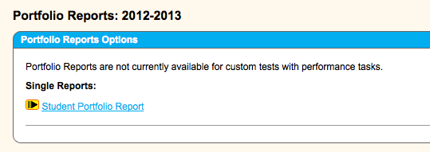

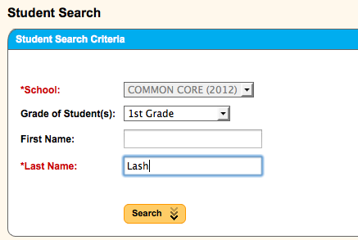
Identify by student last name and then click on the student. Next, click “get report.”

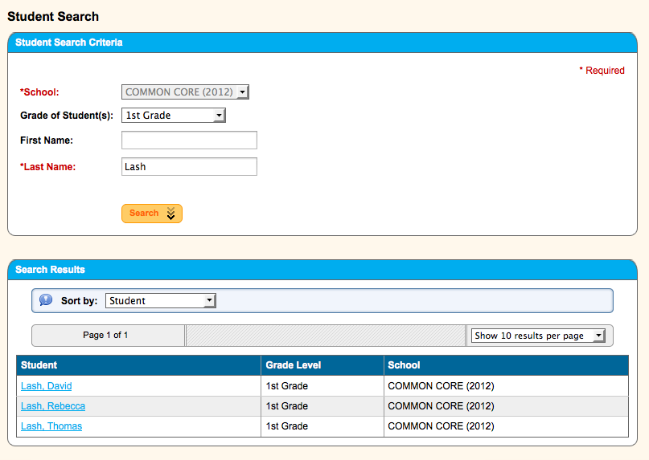
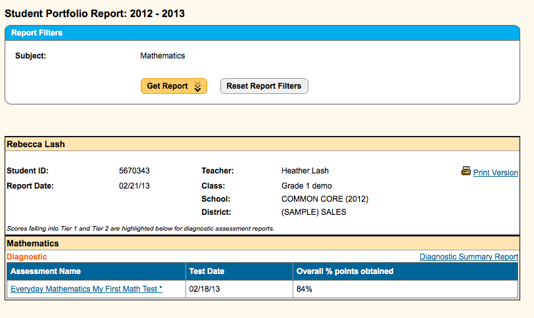

This will show the student progress from one assessment to the next. Click on “Diagnostic summary report” to view more detail from one assessment to the next on math strands.

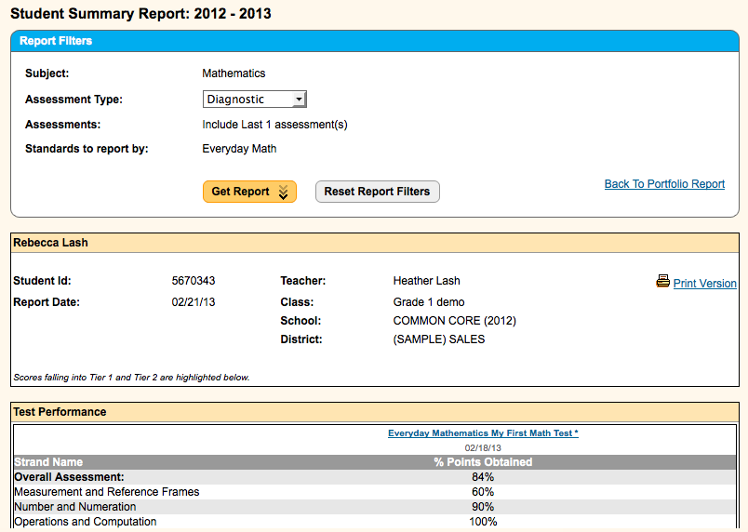
SUMMARY Reports

This report is great for looking at the class as a whole to view progress from one assessment to the next as well as strand data.

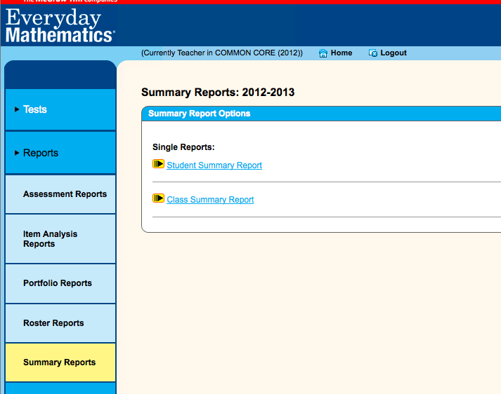

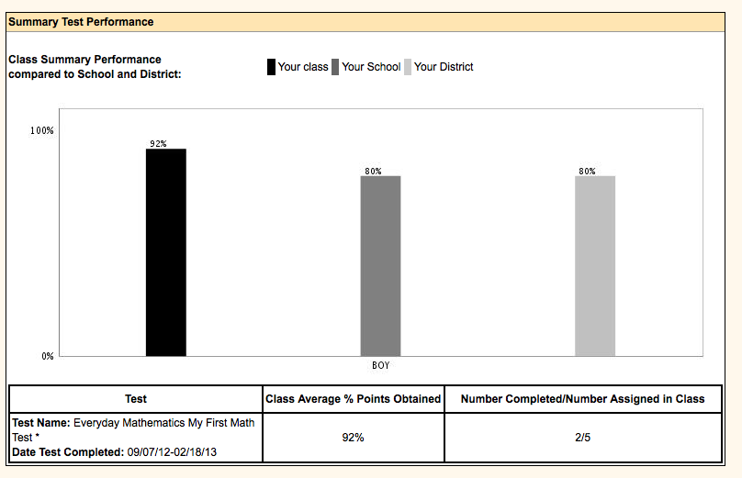
BOY stands for Beginning of Year assessment

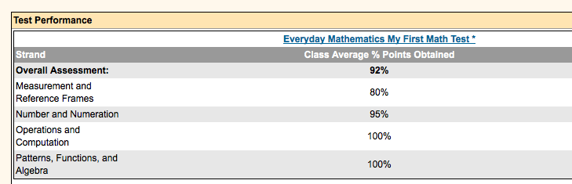

This area will compare all assessments your class has completed to show growth for the class as a whole.

